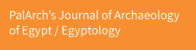

A SEMIOLOGICAL DISCOURSE ANALYSIS OF US- TALIBAN RELATIONSHIP IN PAKISTANI ENGLISH NEWSPAPER

Dr. Muhammad Akbar Sajid¹, Memoona Nazir², Saeed Shaker³, Shafqat Hussain⁴
¹Assistant Professor NUML, Multan
²Assistant Controller, Cholistan University Bahawalpur
³ Lecturer Department of Education, NUML, Multan
4 M. Phil Scholar, Times Institute Multan
Email: ¹masajid@numl.edu.pk

Dr. Muhammad Akbar Sajid, Memoona Nazir, Saeed Shaker, Shafqat Hussain. A Semiological Discourse Analysis Of Us- Taliban Relationship In Pakistani English Newspaper -- Palarch’s Journal Of Archaeology Of Egypt/Egyptology 19(3), 1063-1072. ISSN 1567-214x

Key Words: Us- Taliban Relationship, Semiotic Discourses, Constucted Reality, Focus Group Discussion

ABSTRACT
Print media semiotic discourses are regarded as a language in graphic form. They mirror a constructed social reality from the lens of a particular ideological group. US- Taliban relationships have been through various phases in history and are represented likewise through print media semiotic discourses. A recent study decodes the semiotic discourses related to the US- Taliban relations through the semiotic discourses of DAWN (a Pakistan daily newspaper). The data for the study has been collected from January 2019 to December 2019 to show how linguistic and semiotic devices work discursively to shape the readers' perception of US-Taliban relations. The present research employs Hodge and Kress' (2010) model of the Contemporary Social semiotic Approach. The levels of analysis include participants, settings, poses, objects, expression and discourse. The findings of semiotic analysis have also been validated through two focus group discussions. The levels of Focus Group discussions include word, context, frequency and finding the big idea. This has been done to incorporate the general perception of the selected images. It concludes that politics is a game of interests and nothing is absolute in politics. However, print media semiotic discourses are one of the best sites for ideological investment and represent the desired version of a constructed reality by employing the notion of word-picture conjunction.

INTRODUCTION
Political cartoons are a communicative weapon; they play an essential role in print media. The picture speaks more than words in that. Generally, the human sense of sight is considered more reliable than the sense of hearing. Eco (1976) argues that a picture speaks more than a thousand words, and most often, our sense of sight is regarded as more reliable than our sense of hearing. Jakobson (1975) asserts that semiotics speak bubbles and act as meta-language. Barthes (1974) opines that a sign is a trace, clue or mark that stands for both universality and individuality. According to him, semiotics is language in graphic form meant for everybody. Saussure (1916) asserts that semiotics are culturally oriented and carry many interpretations. Besides, he believes that our senses are culturally trained to extract meanings from semiotics. Kristeva (1969) opines that every speech act delivers a message that may be done through language of words, posture, gesture, clothing or any other means in a social context. Semiotic discourses are powerful means for imparting a specific ideology subtly.

According to Saussure (1916), semiotics is a science that studies the life of signs within society. He believes that the most significant feature of political cartoons is to represent language in a denaturalized way because the message delivered through cartoons is always implied. These political cartoons cartoon the dual faces of politicians. Peirce (1931) proposed the system of signifier and signified. The former called it semiology while later called it semiotics. Semiotics helps to understand sign-based behavior. Asmar (1992) believes that print media plays a pivotal role in shaping perception through semiotic discourse.

Political Cartoons as a Genre

Political cartoons most often highlight prevailing socio-political tendencies of a particular context. On the one hand, they break the monotony by providing comic relief and, on the other, satirize some current social issues of grave concern. Most often, problems through them are exaggerated. They typically combine artistic skill, hyperbole and satire to question authority and draw attention to corruption, political violence and other social ills. They serve as an instrument of the hegemony of political power. They are highly packed with layers of meanings, and one needs linguistic and meta-linguistic to deconstruct them comprehensively. Most cartoonists use visual metaphors and caricatures to address complicated political situations and thus sum up a current event with a humorous or emotional picture. However, the place they are given on the pages of a newspaper is of vital significance and highlights the ideological bent of mind of the influential group behind the discourses.

METHODOLOGY EMPLOYED
The research approach used in the study is qualitative because an in-depth analysis of the selected political cartoons has been done to lay a bare bundle of interpretations embedded in the semiotic discourses about US- Taliban relations observed during the mentioned period through the semiotic discourses of the selected newspaper. It has been done to explore possible layers of meanings embedded in the semiotic texts because the social construction of reality can be explored by de/constructing the meta-linguistic features used in the coinage of semiotic discourses. To comprehend and deconstruct how political cartoons published in the selected newspaper represent various phases of US- Taliban relations. The researchers have employed Hodge and Kress's ( 2010) Social Semiotic Approach to Contemporary Communication. The proposed research model works at the following levels:

1. What meanings are being made in the text?
2. How is meaning being made in the text?
3. What resources have been drawn to make meanings in the text?
4. In what social environment is the meaning being made?
5. Whose interest and agency are at work in the making of meaning?

Besides, the researchers have conducted two (02) focus discussions to validate their findings of semiotic analysis. The first group consisted of 06 participants who are MPhil in linguistics. The second group comprises the M Phil participants in subjects other than English linguistics with the same number (06). It was done to know their views in detail because semiotic discourses carry much information and are meant for everybody. They are culturally oriented and are decoded differently by different people. The data collected through focus group discussions were analyzed using Krueger's (2000) model. The levels of analysis of focus group data used in the present research include the word, context, frequency, internal consistency, and finding the big idea. This way, the research methodology employed in the current research is an integrated approach. The rationale behind using an integrated research approach is that the data analyzed in the study consists of three modes i-e linguistics, semiotic, and focus group participants' remarks. To analyze each method of communication, the researchers needed to employ the relevant research model accordingly. The selected political cartoons about the representation of the US- Taliban representation have been analyzed by employing the devised tri-angular research model.

Fig.01

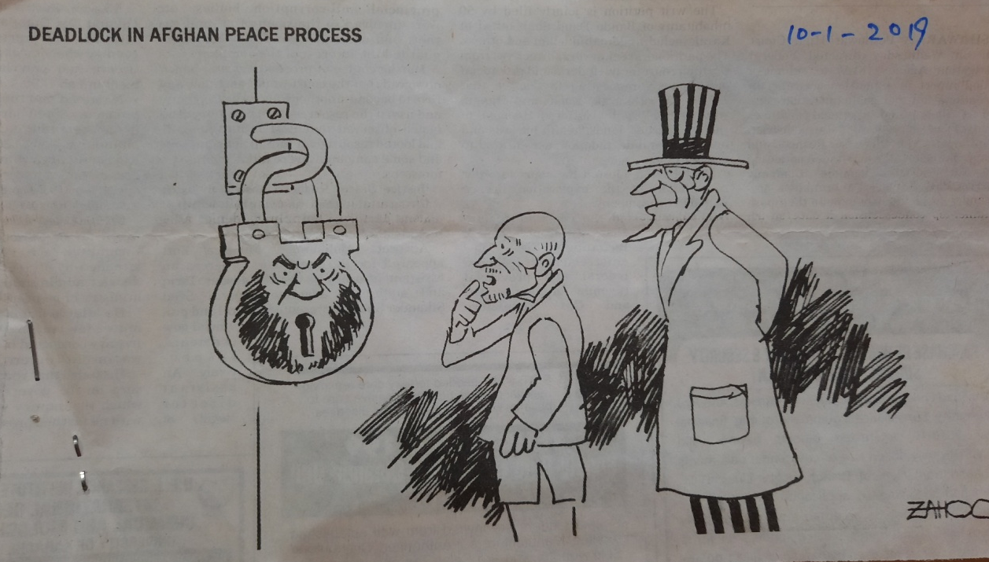

ANALYSIS AND DISCUSSION
According to Wodak (2001), discourses are rooted historically, so they cannot be analyzed comprehensively and systematically without knowing the context. The Taliban were under the thumb of America in the past and were exploited as desired by the controlling master of the time, America. The semiotic under analysis comprises the linguistic text, which is as under:

"DEADLOCK IN AFGHAN PEACE PROCESS"
Hodge and Kress (2010) argue that in semiotic discourses word-picture conjunction technique propagates the desired ideology insidiously, and the intended message is conveyed more comprehensively. Similarly, the concept of 'Deadlock' has been highlighted here in the semiotic by creating a word-picture conjunction analogy. In some instances, words cannot be understood without pictures. It is true when applied to the semiotic under analysis. The literal meaning of the word deadlock is a situation, typically one involving opposing parties, in which no progress can be made. It is a type of fundamental disagreement. The lock shown in the semiotic seems dead and rusty. It implies that now it is harder to open the long-standing deadlock between Taliban and American administrations regarding peace talks in Afghanistan. The lock carries the picture of a Talibans' leader that perhaps waited for a long and found no way out locked the door, which might lead them to hold dialogues. The man's angry face on the lock represents that now Talibans are no more inclined to hold peace talks with America because their terms and conditions have not been fulfilled.

On the contrary, only the interests of America have been focused on. Using capital letters in the linguistic text implies that the reader carries an important message, and the producer of the intended ideology desires that it should be more visible to all the stakeholders. Therefore, this typographic technique, a prominent feature of print media discourses, has been employed here to convey the meanings.

Phillipson (1997) states that print media discourses reflect some existing social reality or constructed version of the truth to the readers to shape their mindset accordingly. Here, in the picture, the Afghan and American governments' representatives have been represented positively. They are at the door of the Taliban to hold dialogues to restore peace in Afghanistan, but the locked door and the frowned-upon picture of the Talibans' leader connote that they are unwilling to continue peace talk. The lock's keyhole is represented by the tightly closed lips of the angry Talibans' leader. It connotes that the Taliban are no more willing to hold a talk about the peace process in Afghanistan. This gesture on the part of the Taliban has extremely surprised the representatives of the Afghan and American governments, as is evident from their facial expressions. The wide opened mouth with a finger on the lip of the representative of the Afghan government illustrates his surprised state of mind on what has been done by the Taliban. He has been represented as an intermediary (mean agentive) between the Taliban and America. The arms at the back of the representative of America represent him in a relaxed posture, but the anger on his face highlight that he is also surprised by looking at the locked door. The concept of using persons as state metaphors has also been shown in the picture because the three men represent their respective groups.

Eco (1976) argues that semiotics are culturally oriented and carry a bundle of interpretations. Similarly, the caricature under analysis, if decoded keeping in view the Afghan culture, connotes an unpleasant act by the Taliban by not being present for dialogue with the representatives of the Afghan and American governments. Strangely, the host's door was locked by inviting the guests. The representatives of the Afghan and American governments are just like guests at the house of the Taliban. It seems somewhat untraditional, especially in Pathan culture. They are supposed to entertain even the enemy at their home. But as mentioned earlier, those semiotics carry a bundle of interpretations. The locked door with the picture of the Talibans' leader might have a history. They might have been exploited in the past under the guise of dialogue, and their propositions might have been turned down, leading them to this violent action.
Kress (2010) maintains that Caricatures are metaphorical representations of speech. In this regard, it is essential to note that the American representative is wearing the flag of his country, which suggests that the American representative has an identity of his own. On the other hand, the Afghani president is bareheaded, which implies that he does not have any peculiar identity. The boggled face of the Afghan president highlights that he is apprehensive about his future because if the peace process is achieved through dialogues between America and the Taliban, what would be the status of his government. Perhaps he would have no ground to stand on. This has made him more worried, as the picture shows. Moreover, the heaps and haphazardness delivered illustrate vicissitudes between America and the Taliban.

Fig 02

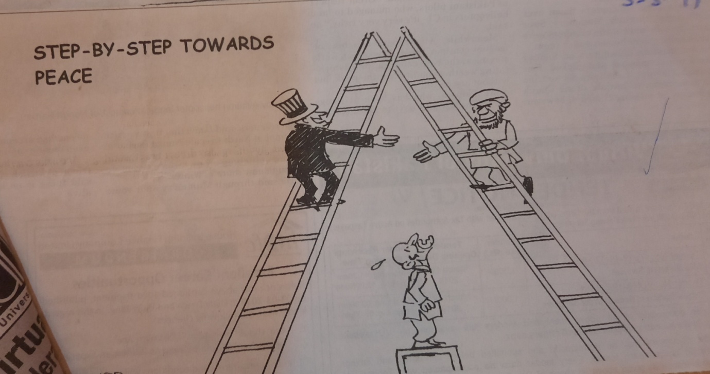

ANALYSIS AND DISCUSSION
Dijk (2004) asserts that print media discourses are highly politicized, and people belonging to in-group are represented positively and vice versa. Similarly, Boorstin (1963) opines that people see mediated images more than reading the words. According to him, visual imagery is more persuasive than words and semiotics are meant for everybody and are decoded likewise.

Here in this image, the use of linguistic text' STEP- BY- STEP TOWARDS PEACE' carries different interpretations at explicit and implicit levels. The expression 'Step-by step connotes that ideological differences cannot be resolved. Instead, such deep-rooted clashes need a certain amount of time to be determined. Similarly, the confrontations between the Afghan Taliban and the American administration are deep-rooted and will take time to be resolved. A gradual and step-by-step process is required in this regard. The two ideological groups have through various phases during history where their relations are concerned. At times the Taliban have been blue-eyed for America (when they were fighting against Russia for the interest of America). Then the time came also when friends in the past turned bitterly against each other. Once again, efforts are being made to restore good ties through step-by-step peace talks. The ladders in the picture metaphorically represent both parties' progress so far. The semiotic analysis illustrates that though the Taliban and the American administration are close enough to bridge the gap, they have a particular gap. This has been shown through the right hands of both the representatives of their respective ideological groups.

Kress (2010) opines that semiotics are highly ideological, and they are drawn purposefully. Each aspect involved in their drawing carries some ideology in it. Similarly, the steps covered by the American representative are five in number, whereas the steps covered by the Taliban representative are six in number. This implies that perhaps the Taliban are more willing to systematic peace talk and are one step ahead in this regard. On the other hand, the American representative is standing at the fifth step, perhaps because the two can still not shake hands with each other (to overcome their ideological clashes). One thing more is essential to note is that the American representative is standing on his two feet on step number five.

In contrast, Taliban representatives though one step ahead, are standing on one foot. Other is somewhat in the air, which may indicate that he is somewhat imbalanced and this might be the reason for the existing distance between the two hands. The picture illustrates that if continuous step-by-step efforts are made, the time may come when both the representatives can be in a position to shake hands with each other (ideological differences may be bridged).

Kristeva (1969) argues that every speech act includes the transmission of messages through the `language' of gesture, posture, clothing, hairstyle, perfume and social context. Sapir (1921) contends that every cultural pattern and social behavior involves direct or implicit communication. However, the semiotic analysis connotes that despite doing their best to restore peace in Afghanistan so far, the parties have not achieved their desired goals because of some fundamental cultural and religious differences. The way these ladders have been placed seems somewhat insecure. Therefore, both the representatives are holding the ladders on their respective sides with their left hands. The ladders shown in the picture also resemble a road going ahead. As far as the representation of the Afghan government is concerned, it seems to be in a problematic and boggled situation. The semiotic illustrates that the representative of the afghan government has been left far behind, and now things seem out of their reach. The open mouth of the representative of the Afghan government and tightly erected neck symbolize feelings of worry and amazement on his part. He has been given a very miniature status. To him, both the representatives of the Taliban and America seem like giants far away from his reach now. Moreover, the concept of persons as state metaphors has also been used here in this semiotic because the three persons shown in the picture stand for their respective ideological groups. The use of the typographic technique in the form of capital letters is also ideological. It implies that something significant will happen because this technique is used when the producer of an ideology wants to propagate an important ideological message to the target audience. The overall impression of the semiotic is to convey the message to the target audience about the US-Taliban relationship. This ideological function has been performed using the concept of word-picture conjunction, linguistic and visual practices and employing the typographic technique.

FOCUS GROUP FINDINGS
Krueger (2000) maintains that focus group discussions are significant means of data collection and are used for in-depth ideological analysis in qualitative research. Similarly, to know the general perception of the selected caricatures about the representation of US- Taliban relations through print media semiotic discourses, the present study employs a focus group discussions method to validate the researchers' analysis of semiotics. For this purpose, two focus discussions were conducted. The first group comprises the participants who are in M.Phil. English. In contrast, the participants in the other group were M.Phil. in other subjects like Management Sciences, Education, IR, Islamic Studies, Mathematics, and History. The selected images for discussion were provided to the participants a week before. They were reminded repeatedly about the date of the discussions. All the participants enjoyed expressing their views about semiotics. The remarks of some of the participants have been provided in this analysis section to extract the overall impression from their comments.

One of the focus group participants, while sharing her ideas on the semiotic under analysis, said:

"The picture represents a changing scenario showing that America cannot handle the Taliban. There was a time when the Taliban were totally at the mercy of America. Nevertheless, things change very quickly. America has been training the Taliban and providing them to use them against Russia. It never imagined such behavior from them."

Another participant, in his turn, expressed his perception of the caricatures, which is as under:
"These political cartoons represent three different ideologies and mindsets. It is more of a clash of ideologies. One important thing is that ideologies are regarded as false consciousness. They are never absolute but are interests based. When one's purpose is obtained, one can change his/her ideology. This is what these semiotics represent. Politics is a game of interests. The three persons in the first figure are trying to achieve their interests by politicizing the situation."

Another remarked:

“According to American perception, Taliban are rigid, fundamentalists and hardliners. They do not believe in table talk. Rather, they want to decide their issues through violence. The frown and angry face of the Talibans’ representative illustrates the western perception of Islam and the Taliban. However, to my mind, the representative of the Afghan government is just like a puppet between America and Taliban at present.”

A participant, while expressing his perception of the images, said:

"The gap between the hands shown in the semiotic 02 is representative of fundamental and religious clashes. Perhaps this gap cannot be bridged because now the Taliban are more powerful than they used to be in the past. Now America is badly struck in Afghanistan and is also being criticized by its public. Therefore, America is willing to hold peace talks with the Taliban. However, the future of the present government in Afghanistan is very insecure, and that is obvious from the postures of Mr. Gahni from two semiotics."

Another female participant remarked which is as under:

“The term deadlock connotes that it is not an ordinary lock but an ideological and fundamental clash. However, the picture shows it in the form of literal meanings. Maintaining peace in Afghanistan is not only necessary for America but also for Pakistan, as well, because no country can make progress until its neighbor is peaceful and prosperous. It is evident from history that whenever Afghanistan remained unpeaceful, Pakistan felt its effects also. Successful peace talk is also in favor of Pakistan as well.”

The remarks of the focus group participants illustrate that politics is a game of interests and nothing is absolute in it. The words most frequently used by the participants are ideological clash, the game of interests and the double standard of America, Afghan government as a puppet, long history of US-Taliban relations etc. After analyzing participants' remarks, the overall impression is that both America and the Taliban are playing tricks on each other. As long as the Taliban applied to America, it remained supported them. When interest is no longer the same, Talibans are represented as rigid and fundamentalists. Almost all the participants remained consistent with their ideas, and none changed his/her stance after listening to others. Hence, the element of consistency was observed in the data. The big picture of the analysis is that now it is no more beneficial for America to stay in Afghanistan. Therefore, she is searching for excuses to withdraw from America. However, the Taliban also want to have their demands realize

CONCLUSION
The selected data analysis reveals a noticeable change in American perception and representation of the Afghan Taliban. America, which used to be bossy towards Pakistan and the Taliban and kept demanding the mantra of 'Doing More' now, seems to be moving on the back foot. It wants an honorable withdrawal from Afghanistan because of some internal and external pressure. The Taliban also want to have their demands realized. The analysis of data collected from the semiotic discourses of Pakistani Print Media (DAWN) highlights a paradigm shift as far as American representation is concerned through previous years. In the past, America was represented as Super-ordinate, but now she is willing to hold table talks to restore peace in Afghanistan. America wants to withdraw from Afghanistan after being here almost for two decades. America wants to show its positive image that its policies remained successful in Afghanistan. Peace talk is an attempt at face-saving by America. One cannot impose one's ideology for long on others. Circumstances keep on changing politically and geographically. Still another significant finding of the research is that semiotic discourses are a significant genre of print media and word-picture conjunction significantly shapes the target audience's mindset. Hence, the present study concludes that print media semiotic discourses, on the one hand, shape the perspective of its readers and, on the other hand, represent political changes taking place in the global scenario. The impact of political cartoons on the people in the backdrop of Pak- Us relations is of vital significance.

REFERENCE
Asmar, C. (1992). 'The Arab-Australian Experience,' in M. Goot and R. Tiffin (Eds.), Australia's Gulf War, Carlton: Melbourne University Press.
Barthes. R (1974). Muthologies. New York: Wang.
Boorstin, D. J. (1963). The image: a guide to pseudo-events in America, USA, Harper & Row.
Eco, U. (1976). A Theory of Semiotics. Bloomington: Indiana University Press.
Jakobson, R. (1975). Coupdel’oeilsur le Development de la Semiotique. Studies in Semiotics. Bloomigton: Indiana University Press.
Jacobson, R. (1975). Coupdel'oeilsur le development de la Semiotique, Studies in Semiotics, Research Centre of Language and Semiotic Studies. Indiana: Bloomington.
Kress, G. & Hodge, B. (2010). Language an Ideology. London: Routledge and Kegan Paul.
Kristeva, J. (1969). Semiotic. Researches Pour Une Semanalyse. Paris: Seuil.
Krueger, R.A. (2000). Designing and conducting focus group interviews. October, available at: www.sph.umn.edu/img/assets/18528/FocGrp_Krueger_Oct02.pdf
Peirce, C. (1931-58). Collected Papers of Charles Sanders Peirce, Vol 1-8, C. Hartshome & P. Weiss (Eds.). Cambridge & Mass: Harvard University Press
Phillipson, R. (1997). Linguistic Imperialism. Oxford: Oxford University Press.
Saussure, F.de. (1916). Course de Linguistique Generale. Paris:Payot.
Sapir, W (1921). Man Made Language. London: Routledge & Kegan Paul
Dijk, T. A. V. (2003). Discourse as Social Interaction. London: Sage Publication.
Wodak, R. (2001). Disorders of discourse. London: Longman

