EMPLOYEES’ PERCEPTION ON JOB SECURITY IN ORGANIZATION BASED AT SAUDI ARABIA

Rahf Anas Abed¹ Uzma Javed²
^{1,2}College of Business, Effat University, Qasr Khuzam Jeddah Saudi Arabia,
E.mail: ¹raabed@effat.edu.sa
² ujaved@effatuniversity.edu.sa

Rahf Anas Abed, Uzma Javed. Employees’ Perception On Job Security In Organization Based At Saudi Arabia-- Palarch’s Journal Of Archaeology Of Egypt/Egyptology 18(14), 219-230. ISSN 1567-214x

Additional Keywords And Phrases: Job Security; Job Performance; Employee; Contract;

ABSTRACT
This study was carried out to evaluate employees perception on job security in Saudi Arabia. This study was conducted based on quantitative method. In this study, sample comprised of 50 employees and 50 managers from public organization based in Saudi Arabia. Questionnaire survey was used for data collection. The finding of this work has shown that 39% of the employees agreed that they are worried and affected by job insecurity. Furthermore, 45% of the employees have disagreed that their job has become more interesting from the previous years. In addition, 48% of the employees have disagreed that their organization has an effective employment contract. On the other hand, 33 % of the employees have agreed that their work is not appreciated based on employment contract. Moreover, 38% of the employees have disagreed that the organization carries out free and fair performance evaluations. Thus, it is concluded that employees are concerned about job security in their association.

CCS CONCEPTS • Insert your first CCS term here • Insert your second CCS term here • Insert your third CCS term here

ACM Reference Format:

First Author’s Name, Initials, and Last Name, Second Author’s Name, Initials, and Last Name, and Third Author’s Name, Initials, and Last Name. 2018. The Title of the Paper: ACM Conference Proceedings Manuscript Submission Template: This is the subtitle of the paper, this document both explains and embodies the submission format for authors using Word. In Woodstock ’18: ACM Symposium on Neural Gaze Detection, June 03–05, 2018, Woodstock, NY. ACM, New York, NY, USA, 10 pages. NOTE: This block will be automatically generated when manuscripts are processed after acceptance.

Introduction
Job security is described as the probability that a person is able to retain their employment status or rather the probability that they can become unemployed [1]. In this period of globalization, the aggressive condition faced by associations encourages different types of business adaptability which trigger representatives' stresses over their job security and employment coherence [2]. Thus, this has caused representatives to be increasingly mindful of the issue of professional stability. Hence, representatives positioned job security as the most significant factor for employment fulfillment [3].

It is essential to look for viable systems to enable representatives to adapt to work uncertainty with the goal that they may remain engaged with work and performance, especially under strenuous financial conditions [4]. Thus, association management needs to know under what conditions representatives' negative reactions to work instability can be cradled. Job security is believed to affect the performance of an employee in the workplace [5]. At the point when managers of the employees neglect to give secure occupations, representatives are probably going to encounter work pressure and negative passionate responses that may influence their work exertion [6]. As a standout amongst the most noticeable and regular occupation stressors, work instability has been observed to be contrarily connected with representatives’ occupation fulfillment, association commitment, work engagement, trust in the association, and wellbeing [7].

Various studies have been reported in analyzing job security and employees work performances. Wang et al.[8] examined the connection between occupation insecurity and representatives' performance, and found that job insecurity was contrarily connected with employment execution through work commitment. Imran et al.[9] investigated the connection between job stability, hierarchical equity and workers performance, and found that deficiency of work security, authoritative equity and occupation fulfillment can be a reason for reduction in representatives work execution. De Cuyper et al.[10] studied the connection between occupation stability and representatives execution, and found that workers displayed low work responsibility and execution because of occupation frailty. Keim et al. [11] investigated workers' view on job security, and found that job frailty is related with having an inner locus of control, lower measures of job vagueness and job dissension. Lam et al.[12] analyzed connection between occupation insecurity and hierarchical citizenship conduct, and found that position insecurity among representatives is associated with work performance and authoritative citizenship conduct. Vander Elst et al.[13] performed psychometric assessment on occupation insecurity scale crosswise over five European nations, and found that occupation frailty was related with hierarchical responsibility and representatives work execution. De Spiegelaere et al.[14] inspected whether occupation insecurity influences the creative work conduct of representatives, and found that job instability is directly related to imaginative work conduct through work commitment. Callea et al.[15] examined the connection between subjective occupation uncertainty, hierarchical citizenship conduct and occupation execution , and found that position job insecurity has critical impact on authoritative citizenship conduct and representatives work execution. Lee et al.[16] inspected the connection between occupation insecurity and turnover expectation among representatives and found that position insecurity was emphatically recognized with turnover goal as it caused decrease in employees work performance. Darvishmotevali et al. [17] analyzed the connection between occupation insecurity and employment execution, and found that mental stress intercedes the impact of job instability on employment performance.

Job insecurity has increasingly become a significant focus for today’s business organization. Specifically, in recent times, the financial crisis caused a rise in feelings of insecurity, stress and concern for many employees about the survival and the existence of their employment. In Saudi Arabia, the employment circumstance has transformed significantly over the last five years, as deteriorating labor market situations was observed [18]. It has caused contract-based employees and permanent based employees to face the issue of job insecurity. Thus, this work was done to analyze the employee’s perception on job security in organization based at Saudi Arabia.

METHODOLOGY
In this research study, quantitative method was used to understand and interpret impact of job insecurity on performance of an employee. The sample of this work comprised of 50 employees and 50 managers that were selected from different public organizations within the Kingdom of Saudi Arabia. Both primary and secondary data collection methods have been employed in this work. For primary data, the authors have used questionnaire methods. For secondary data, the authors have referred to book, journal and article publication. Data collection was done using questionnaire survey. The data were analyzed in terms of basic statistic and was presented in graphical form.

Result And Discussion

Demographics Characteristics of sample

According to the demographic characteristics of the sample population, 65% of the respondents were male and 35% of the respondents were female. Based on Figure 1, it is observed that 44% the sample population lies in the age group of 20 -30 years. 29 % of the sample population are of age between 41-50 years and 25 % of the sample population lies in age group of 31-40 years. Only 1% of the participants are above 50 years of old.

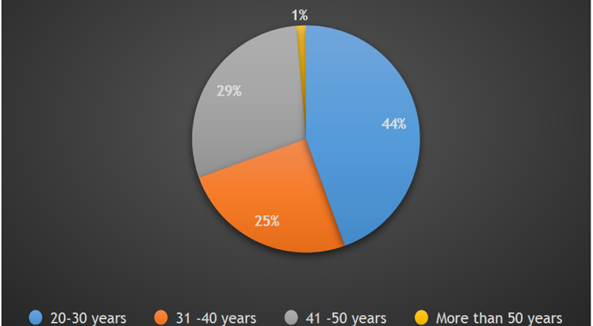

Figure 1: Age of the Respondents

Based on Figure 2, in terms of educational qualification of the respondents, 38% of the sample population are high school graduate and 34 % of respondents have bachelor degree. And moreover, 14 % of the sample population have diploma and 14 % of sample have master’s degree.

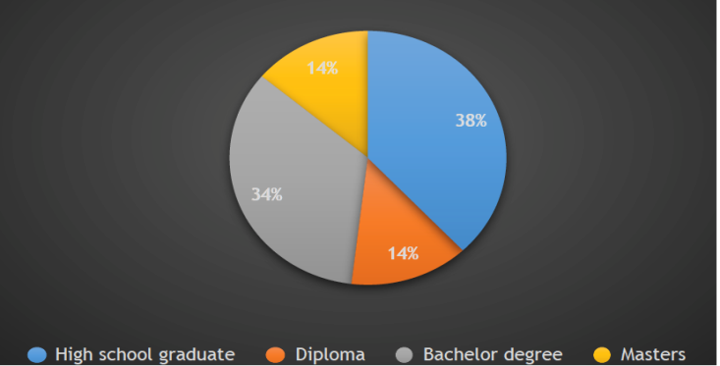

Figure 2: Highest level of education of the respondents

There is diverse job title observed in this survey process, however the majority of the respondents are students, investment engineer, dentist and marketing persons. Apart from this, there are people from higher positions such as director, CEO, senior credit officers and manager in different organizations. Furthermore, respondents are associated with nursing and digital marketing.

Based on Figure 3, in terms of the length of the service in organization, the majority of sample population (54 %) are working for less than 5 years in their respective organizations. 18 % of the population are working for more than 15 years and 15 % of the sample population are working for 5 to 10 years. Lastly, 13 % of the sample populations are working for 11 to 15 years in their organizations.

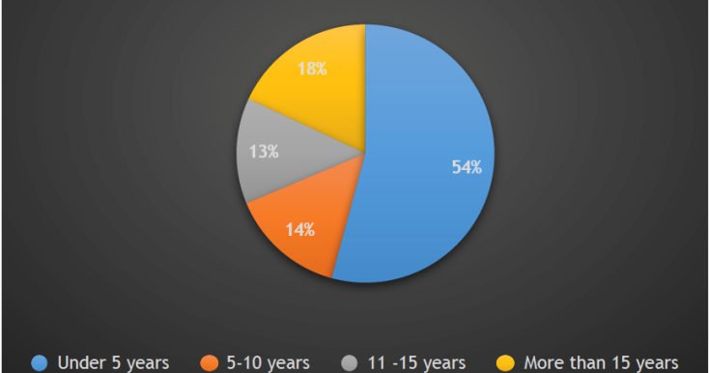

Figure 3: Length of service

Questionnaire Analysis

In this work, the respondents were subjected question related job security and job performance. Thus, the outcomes question statement are discussed in this section. Based on Figure 4, the employees were asked “if they are worried of job security in their organization”. Thus, based on Figure 4, 19% of the respondents who strongly disagree, 11% of the respondents who disagreed, 31%of the respondents chose neutral. This is compared to 16% of the respondents who agree and 23% of the respondent who strongly agree with the question statement. Thus, it is deduced that majority of the sample population are suffering from job insecurity.

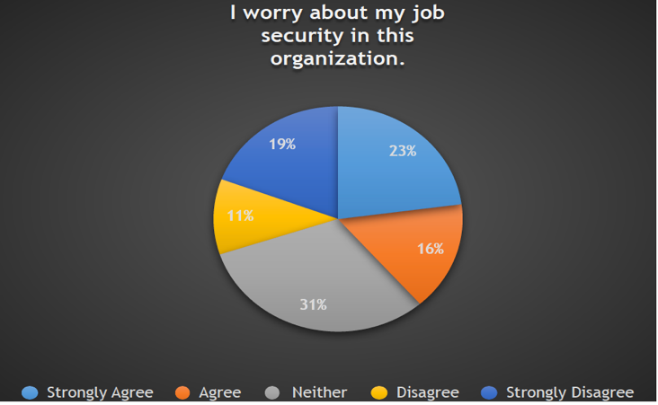

Figure 4: Employees worry about job security in their organization

Based on Figure 5, the employees were asked “their job has become more interesting from the past years”. Thus, based on Figure 5, 22% of the respondents who strongly disagree, 23% of the respondents who disagreed, 29%of the respondents chose neutral. This is compared to 19% of the respondents who agree and 7% of the respondent who strongly agree with the question statement. Thus, it is deduced that majority of the respondents disagrees with the condition. This proves that employees are not satisfied with their job in their respective organizations.

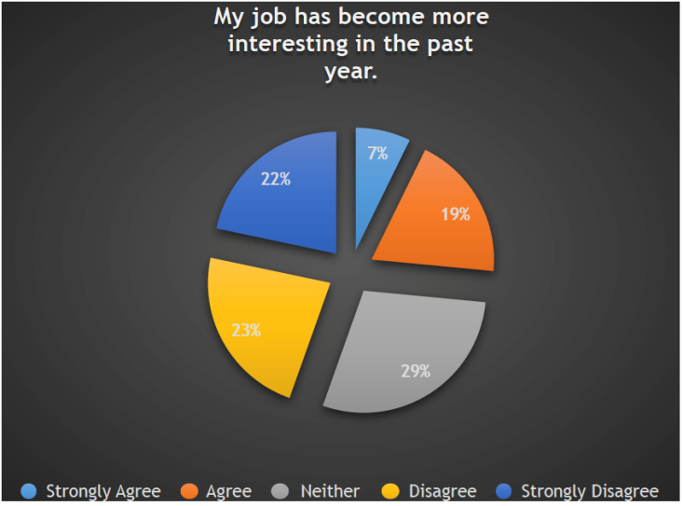

Figure 5: Employees job has become more interesting from the past year

Based on Figure 6, the employees were asked “if their organization has an effective employment contract”. Thus, based on Figure 6, 23% of the respondents who strongly disagree, 25% of the respondents who disagreed, 35%of the respondents chose neutral. This is compared to 7% of the respondents who agree and 10% of the respondent who strongly agree with the question statement. Thus, it is deduced that the majority of the respondents strongly disagreed that they have effective employment contract.

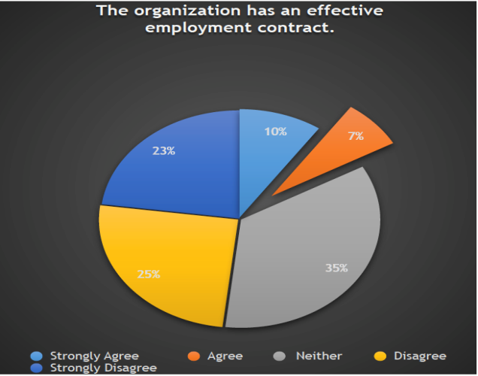

Figure 6: The organization has an effective employment contract

Based on Figure 7, the employees were asked “if they feel that their work is not fully appreciated as per the term of employment contract”. Thus, based on Figure 7, 17 % of the respondents who strongly disagree, 19% of the respondents who disagreed, 30% of the respondents chose neutral. This is compared to 25% of the respondents who agree and 8% of the respondent who strongly agree with the question statement. Thus, it is deduced that the sample population’s opinion is divided regarding work is not fully appreciated as per the term of employment contract.

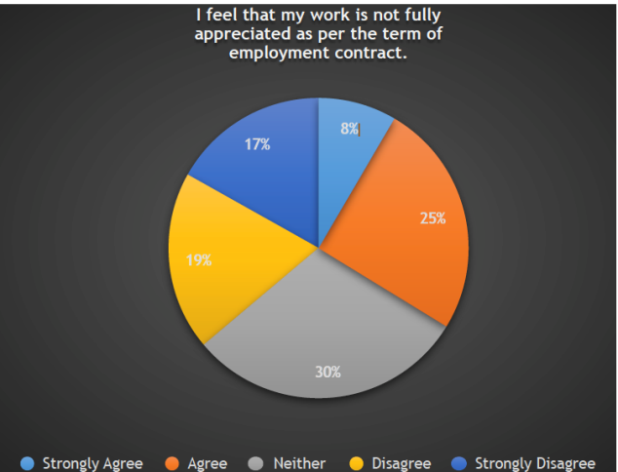

Figure 7: Employees work is not fully appreciated as per the term of employment contract

Based on Figure 8, the employees were asked “if their employer has improved their working condition from previous years worked”. Thus, based on Figure 8, the 16 % of the respondents who strongly disagree, 19% of the respondents who disagreed, 29% of the respondents chose neutral. This is compared to 24% of the respondents who agree and 12% of the respondent who strongly agree with the question statement. Thus, it is deduced that majority of the sample population’s working condition has been improved from previous years.

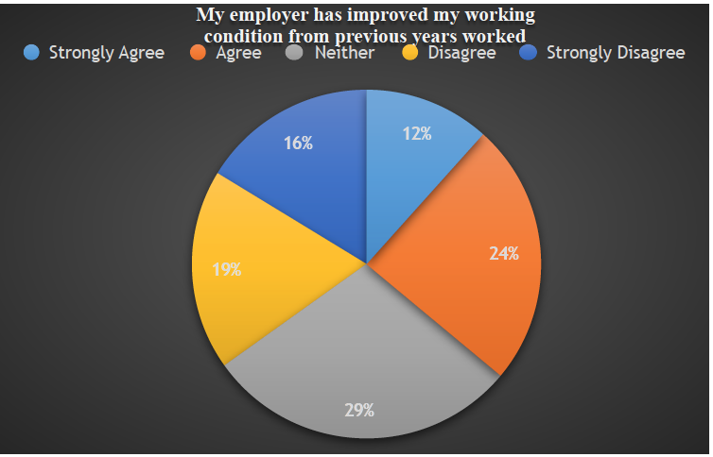

Figure 8: Employer has improved working condition from previous years

Based on Figure 9, the employees were asked “ if their organization carries out free and fair performance evaluations”. Thus, based on Figure 9, the 13 % of the respondents who strongly disagree, 25% of the respondents who disagreed, 34% of the respondents chose neutral. This is compared to 16% of the respondents who agree and 12% of the respondent who strongly agree with the question statement. Thus, it is deduced that the majority of the respondents disagrees with the condition.

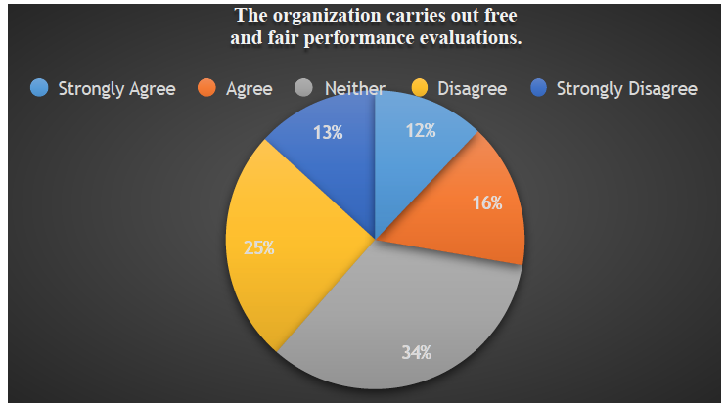

Figure 9: The organization carries out free and fair performance evaluations

Based on Figure 10, the employees were asked “ if their organization offer any new promotions that fit their qualifications”. Thus based on Figure 10, 13 % of the respondents who strongly disagree, 14% of the respondents who disagreed, 45% of the respondents chose neutral. This is compared to 19% of the respondents who agree and 8% of the respondent who strongly agree with the question statement. Thus, respondents strongly disagreed that their organization offers any new promotions that fit my qualifications.

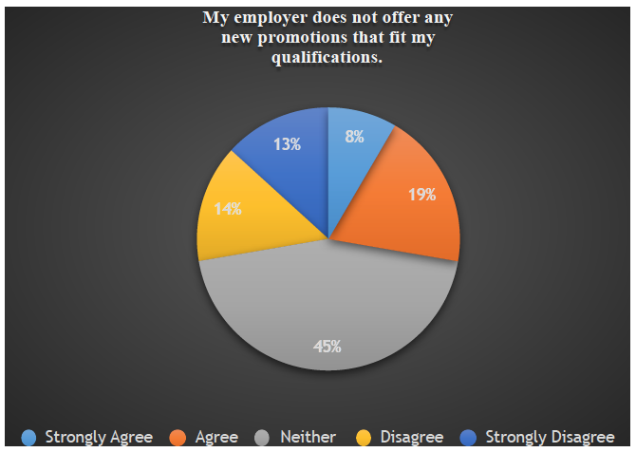

Figure 10: Employer does not offer any new promotions that fit employees’ qualifications

Based on Figure 11, the employees were asked “ if they are planning to demand a new pay increase”. Thus, based on Figure 11, the 18 % of the respondents who strongly disagree, 17% of the respondents who disagreed, 40% of the respondents chose neutral. This is compared to 20% of the respondents who agree and 5% of the respondent who strongly agree with the question statement. Thus, it is deduced that majority of the respondents disagrees with the condition. This proves that respondents are not satisfied with their pay and remuneration.

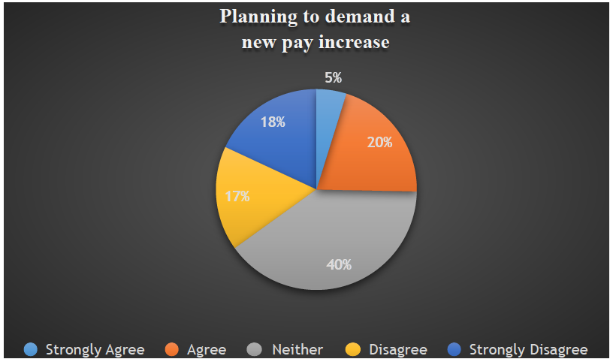

Figure 11: Employee planning to demand pay increase.

Based on Figure 12, the employees were asked “ if they feel their work does not meet all their personal needs”. Thus based on Figure 12, 18 % of the respondents who strongly disagree, 11% of the respondents who disagreed, 30% of the respondents chose neutral. This is compared to 29% of the respondents who agree and 12% of the respondent who strongly agree with the question statement. Thus, it is deduced that majority of the sample population are satisfied that their job is fulfilling their personal needs.

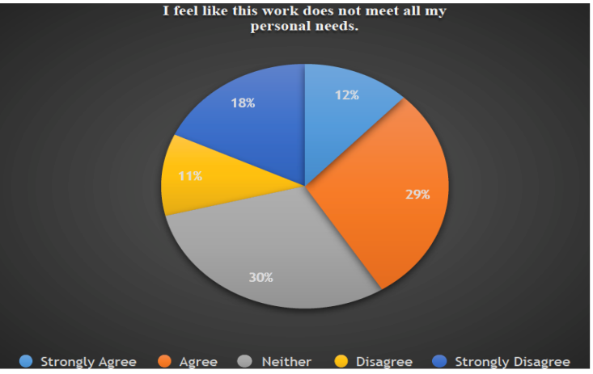

Figure 12: Employee feel like this work does not meet all of employees personal needs

Based on Figure 13, the employees were asked “ if their organization does not have a rigid compensation and reward policy”. Thus, based on Figure 13, 17 % of the respondents who strongly disagree, 14% of the respondents who disagreed, 37% of the respondents chose neutral. This is compared to 20% of the respondents who agree and 11% of the respondent who strongly agree with the question statement. Thus, it is deduced that majority of the sample population disagrees with the condition.

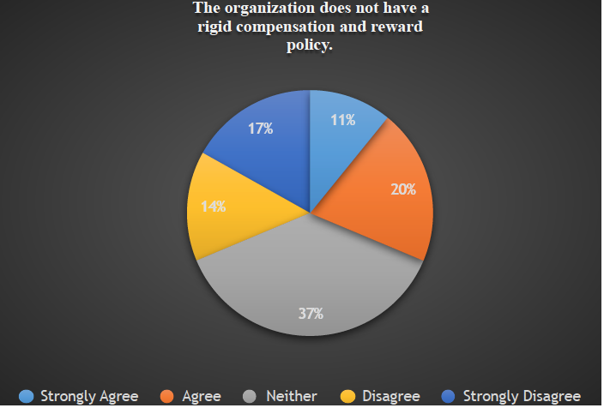

Figure 13: The organization does not have a rigid compensation and reward policy

Overall Discussion

In this work, the main aim was to determine the relation between job security and the perception of the employees. As observed from results, most of the employees in Saudi Arabia are worried about job security in their organization. The outcome of this work is line with the work of Schumacher et al.[19] where it was stated that most employees have the tendency to experienced job insecurities at organization and they require reassurance from their organizations. Furthermore, the findings of this work have shown that the majority of the employees agreed that their work is not fully appreciated as per the term of employment contract. Thus, this is one of the reasons, which has caused the feeling of job insecurity. De Cuyper et al. [20] has reported that when organization fails to recognize the work commitment of the employee based on the employment contract, employees will experience the feel of job insecurity and this will effect their work performances. In addition, the outcome of this work has shown that the majority of the employees disagreed that organization carries out free and fair performance evaluations. Shoss [21] work has stated organization should practice fair performance evaluation to comprehend the existence of job insecurity among employees. On the other hand, the employees have disagreed that organization offers any new promotions that fit their work qualifications. Probst et al. [22] has reported that employees’ performance would enhance if proper promotion and recognition is given to avoid deviation in terms of work performance.

CONCLUSION
This work has examined relation of job security and perception among employees in Saudi Arabia. The key findings of this work have shown that most of the representatives in Saudi Arabia are stressed over professional stability in their association. Thus, the authors recommend that the organization need to provide job security assurance towards the employees in order to maintain overall work performance, which in the long run will benefit the organization itself.

REFERENCES
Bassam Mahmoud, A., & D. Reisel, W. (2014). Relating patient satisfaction to nurses' job satisfaction, job security, and obedience OCBs. International Journal of Pharmaceutical and Healthcare Marketing, 8(1), 47-61.
Artz, B., & Kaya, I. (2014). The impact of job security on job satisfaction in economic contractions versus expansions. Applied economics, 46(24), 2873-2890.
Landsbergis, P. A., Grzywacz, J. G., & Lamontagne, A. D. (2014). Work organization, job insecurity, and occupational health disparities. American journal of industrial medicine, 57(5), 495-515.
Gallie, D., Felstead, A., Green, F., & Inanc, H. (2017). The hidden face of job insecurity. Work, employment and society, 31(1), 36-53.
Berglund, T., Furåker, B., & Vulkan, P. (2014). Is job insecurity compensated for by employment and income security?. Economic and Industrial Democracy, 35(1), 165-184.
De Witte, H., Vander Elst, T., & De Cuyper, N. (2015). Job insecurity, health and well-being. In Sustainable working lives(pp. 109-128). Springer, Dordrecht.
Reisel, W. D., & Banai, M. (2016). Job insecurity revisited: reformulating with affect. Journal of Behavioral and Applied Management, 4(1), 1063.
Wang, H. J., Lu, C. Q., & Siu, O. L. (2015). Job insecurity and job performance: The moderating role of organizational justice and the mediating role of work engagement. Journal of Applied Psychology, 100(4), 1249.
Imran, R., Majeed, M., & Ayub, A. (2015). Impact of organizational justice, job security and job satisfaction on organizational productivity. Journal of Economics, Business and Management, 3(9), 840-845.
De Cuyper, N., Sulea, C., Philippaers, K., Fischmann, G., Iliescu, D., & De Witte, H. (2014). Perceived employability and performance: moderation by felt job insecurity. Personnel Review, 43(4), 536-552.
Keim, A. C., Landis, R. S., Pierce, C. A., & Earnest, D. R. (2014). Why do employees worry about their jobs? A meta-analytic review of predictors of job insecurity. Journal of Occupational Health Psychology, 19(3), 269.
Lam, C. F., Liang, J., Ashford, S. J., & Lee, C. (2015). Job insecurity and organizational citizenship behavior: Exploring curvilinear and moderated relationships. Journal of Applied Psychology, 100(2), 499.
Vander Elst, T., De Witte, H., & De Cuyper, N. (2014). The Job Insecurity Scale: A psychometric evaluation across five European countries. European Journal of Work and Organizational Psychology, 23(3), 364-380.
De Spiegelaere, S., Van Gyes, G., De Witte, H., Niesen, W., & Van Hootegem, G. (2014). On the relation of job insecurity, job autonomy, innovative work behaviour and the mediating effect of work engagement. Creativity and innovation management, 23(3), 318-330.
Callea, A., Urbini, F., & Chirumbolo, A. (2016). The mediating role of organizational identification in the relationship between qualitative job insecurity, OCB and job performance. Journal of Management Development, 35(6), 735-746.
Lee, S. H., & Jeong, D. Y. (2017). Job insecurity and turnover intention: Organizational commitment as mediator. Social Behavior and Personality: an international journal, 45(4), 529-536.
Darvishmotevali, M., Arasli, H., & Kilic, H. (2017). Effect of job insecurity on frontline employee’s performance: looking through the lens of psychological strains and leverages. International Journal of Contemporary Hospitality Management, 29(6), 1724-1744.
Azeem, S. M., & Akhtar, N. (2014). Job satisfaction and organizational commitment among public sector employees in Saudi Arabia. International Journal of Business and Social Science, 5(7).
Schumacher, D., Schreurs, B., Van Emmerik, H., & De Witte, H. (2016). Explaining the relation between job insecurity and employee outcomes during organizational change: A multiple group comparison. Human Resource Management, 55(5), 809-827.
De Cuyper, N., & Isaksson, K. (2017). Employment contracts and well-being among European workers. Routledge.
Shoss, M. K. (2017). Job insecurity: An integrative review and agenda for future research. Journal of Management, 43(6), 1911-1939.
Probst, T. M., Jiang, L., & Benson, W. (2018). Job Insecurity and Anticipated Job Loss: A Primer and Exploration of Possible. The Oxford handbook of job loss and job search, 31

